IFT 166 Introduction to Internet Networking
Lab 12
Usable Host Range Investigation
Co-authored by Brandon Clifford

- Set up the following topology in packet tracer.
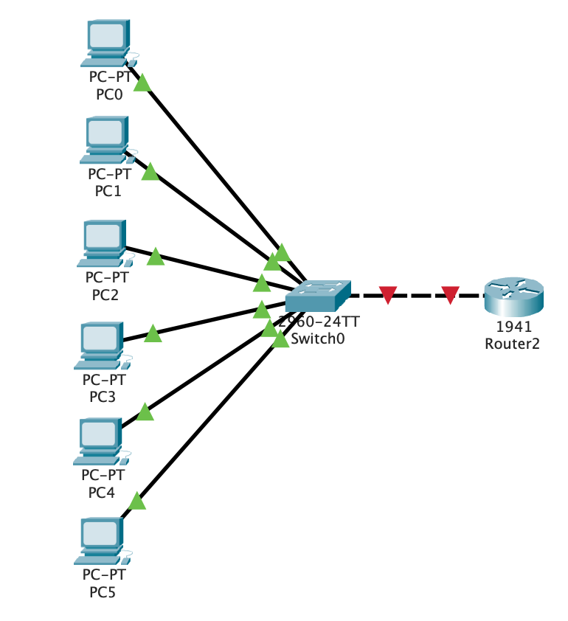
Completed

- We will now configure the router by entering some basic commands (we will do more programming of the router in future labs).
Click on the router and then go to the cli tab, type ‘no’ when asked to ‘continue with configuration dialog’, then hit return on your keyboard. Enter the following commands as (in the image below) by placing the cursor after the ‘Router>’ and type “en”, then hit return and so on….
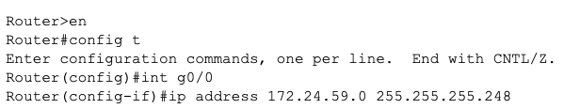
Completed

- You should have received this error

Why was this error produced? | 172.24.59.0 is reserved for the host address therefore cannot be used
What is the valid host range for the 255.255.255.248 subnet? | 172.24.59.1 to 172.24.59.6

- Now accounting for the valid host range, enter in the correct commands for this scenario’s router
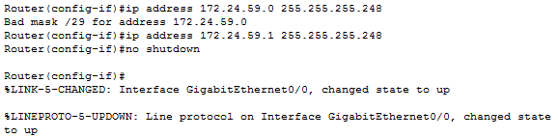
Note: The ‘no shutdown’ command turns on the router interface
Completed

- Your topology should be entirely connected with all ports up (all green) at this point
Completed

- Configure PCs 0 – 4 incrementally starting with the IP address 172.24.59.2 (subnet mask of 255.255.255.248 for all PCs)
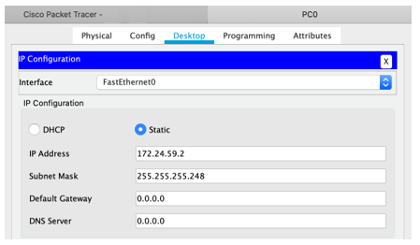
Completed

- Now try to configure PC05’s IP address with 172.24.59.7.
Why won’t Packet Tracer allow you to set this IP address? | 172.24.59.7 is reserved as the broadcast address for the range of hosts given
What is the usable host range for 172.24.59.0 255.255.255.248? | 172.24.59.1 to 172.24.59.6

- You should have realized that 172.24.59.7 is the broadcast address for this subnet mask and is outside of the usable host range.
It is critical to understand which subnet mask will work best for the IP addresses you will be assigning in a network, and to realize that your choice matters when it comes to efficiently utilizing IP addresses.
Completed

- You should be able to ping any other computers with an IP address in the usable host range for this subnet mask at this point
Attach a screenshot of a ping to any computer in this this network to verify connectivity and understanding of usable host ranges. Submit the screenshot in addition to this file.

